MySQL Assignment -2 (DML)

1. Write a SQL statement to insert a record as follows: Employees :
+-------------+-------------+-------------+----------+--------------------+-----------+------------+----------+----------------+------------+--------------+
| EMPLOYEE_ID | FIRST_NAME | LAST_NAME | EMAIL | PHONE_NUMBER |
HIRE_DATE | JOB_ID | SALARY | COMMISSION_PCT | MANAGER_ID |
DEPARTMENT_ID |
+-------------+-------------+-------------+----------+--------------------+-----------+------------+----------+----------------+------------+--------------+
| 100 | Steven | King | SKING | 515.123.4567 |
1987-06-17 | AD_PRES | 24000.00 | 0.00 | 200 |
10 |
| 101 | Neena | Kochhar | NKOCHHAR | 515.123.4568 |
1987-06-18 | AD_VP | 17000.00 | 0.00 | 200 | 10 |
| 102 | Lex | De Haan | LDEHAAN | 515.123.4569 |
1987-06-19 | AD_VP | 17000.00 | 0.00 | 200 | 10 |
| 103 | Alexander | Hunold | AHUNOLD | 590.423.4567 |
1987-06-20 | IT_PROG | 9000.00 | 0.00 | 103 | 60 |
| 104 | Bruce | Ernst | BERNST | 590.423.4568 |
1987-06-21 | IT_PROG | 6000.00 | 0.00 | 103 | 60 |
| 105 | David | Austin | DAUSTIN | 590.423.4569 |
1987-06-22 | IT_PROG | 4800.00 | 0.00 | 103 | 60 |
| 106 | Valli | Pataballa | VPATABAL | 590.423.4560 |
1987-06-23 | IT_PROG | 4800.00 | 0.00 | 103 | 60 |
| 107 | Diana | Lorentz | DLORENTZ | 590.423.5567 |
1987-06-24 | IT_PROG | 4200.00 | 0.00 | 114 | 30 |
| 108 | Nancy | Greenberg | NGREENBE | 515.124.4569 |
1987-06-25 | SA_MAN | 12000.00 | 0.00 | 145 | 80 |
| 109 | Daniel | Faviet | DFAVIET | 515.124.4169 |
1987-06-26 | SA_MAN | 9000.00 | 0.00 | 145 | 80 |

mysql> insert into employees
-> (employee_id, first_name, last_name, email, phone_number, hire_date,
-> job_id, salary, commission_pct, manager_id, department_id)
-> values
-> (100,'steven','king','sking','515.123.4567','1987-06-17','ad_pres',24000.00,0.00,200,10),
-> (101,'neena','kochhar','nkochhar','515.123.4568','1987-06-18','ad_vp',17000.00,0.00,200,10),
-> (102,'lex','de haan','ldehaan','515.123.4569','1987-06-19','ad_vp',17000.00,0.00,200,10),
-> (103,'alexander','hunold','ahunold','590.423.4567','1987-06-20','it_prog',9000.00,0.00,103,60),
-> (104,'bruce','ernst','bernst','590.423.4568','1987-06-21','it_prog',6000.00,0.00,103,60),
-> (105,'david','austin','daustin','590.423.4569','1987-06-22','it_prog',4800.00,0.00,103,60),
-> (106,'valli','pataballa','vpatabal','590.423.4560','1987-06-23','it_prog',4800.00,0.00,103,60),
-> (107,'diana','lorentz','dlorentz','590.423.5567','1987-06-24','it_prog',4200.00,0.00,114,30),
-> (108,'nancy','greenberg','ngreenbe','515.124.4569','1987-06-25','sa_man',12000.00,0.00,145,80),
-> (109,'daniel','faviet','dfaviet','515.124.4169','1987-06-26','sa_man',9000.00,0.00,145,80);

Department :
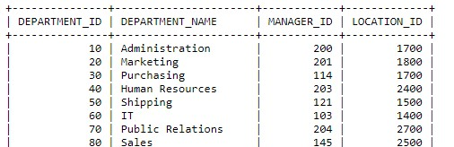
mysql> insert into department
-> values
-> (10,'administration',200,1700),
-> (20,'marketing',201,1800),
-> (30,'purchasing',114,1700),
-> (40,'human resources',203,2400),
-> (50,'shipping',121,1500),
-> (60,'it',103,1400),
-> (70,'public relations',204,2700),
-> (80,'sales',145,2500);
- Write a SQL statement to insert 3 rows by a single insert statement.

- Write a SQL statement to insert one row in jobs table to ensure that no duplicate value will be entered in the job_id column.
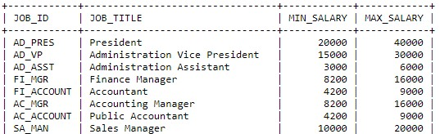
- Write SQL statement to increment salary of each emp by 10%.

- Write a SQL statement to change the email column of employees table with 'not available' for those employees whose department_id is 80 and gets a commission is less than .20%

- Write a SQL statement to change the email column of employees table with 'not available' for those employees who belongs to the 'Purchasing' department.

- Write a SQL statement to change the email and commission_pct column of employees table with 'not available' and 0.10 for all employees.

